Dashboards on Databricks
Brightlearn

Khutso Joshua Monyebodi
2026
SQL Code on Data Bricks
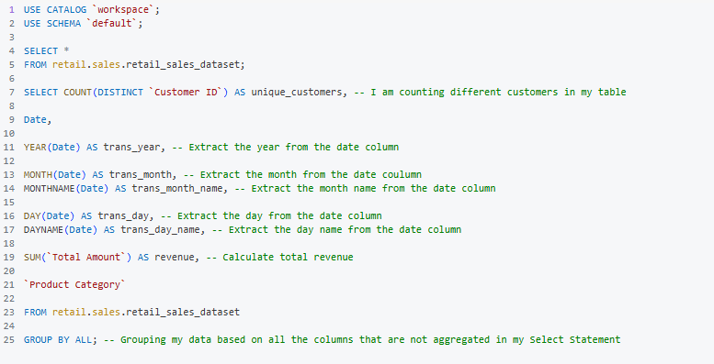
Dashboard Results
